**MongoDB – Complex**

Name:- Muttireddy Bhargavi

Imported the json file into mongodb compass and created database as **restaurants** and collection as **addresses**.

* show databases

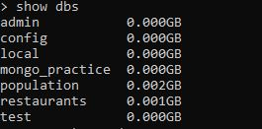

* use restaurants



* db.addresses.find() should print entire json data

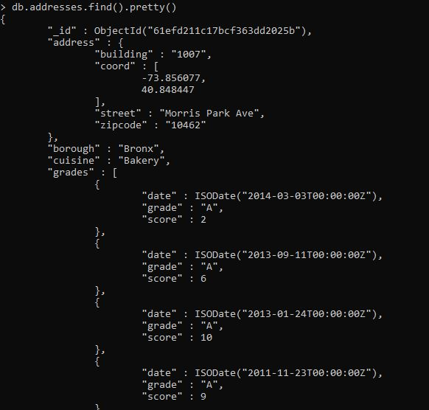

**Exercise Questions**:-

1. Write a MongoDB query to display all the documents in the collection restaurants.



2. Write a MongoDB query to display the fields restaurant_id, name, borough and cuisine for all the documents in the collection restaurant.

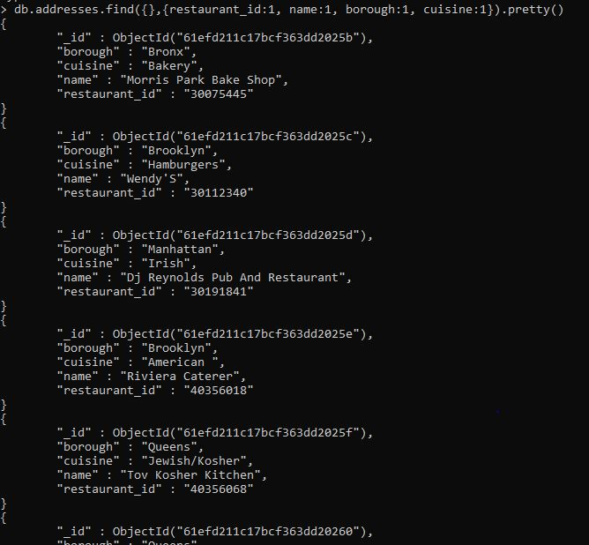

3. Write a MongoDB query to display the fields restaurant_id, name, borough and cuisine, but exclude the field _id for all the documents in the collection restaurant.

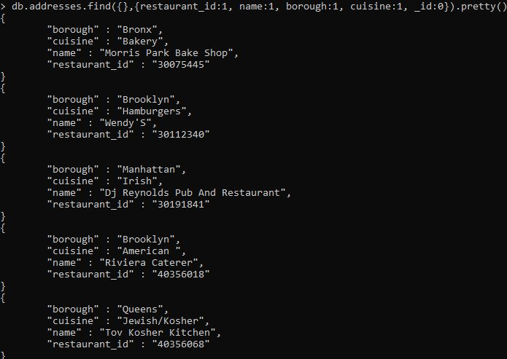

4. Write a MongoDB query to display the fields restaurant_id, name, borough and zip code, but exclude the field _id for all the documents in the collection restaurant.

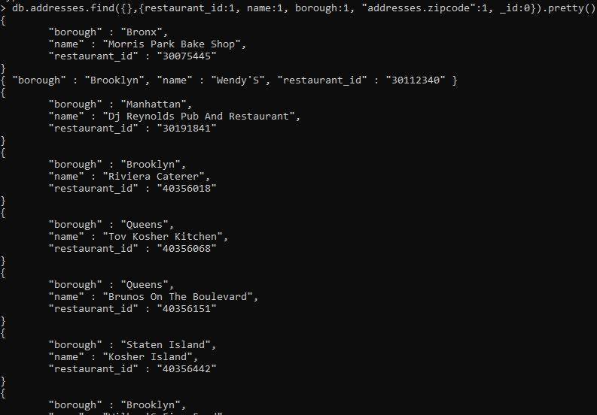

5. Write a MongoDB query to display the first 5 restaurant which is in the borough Bronx.

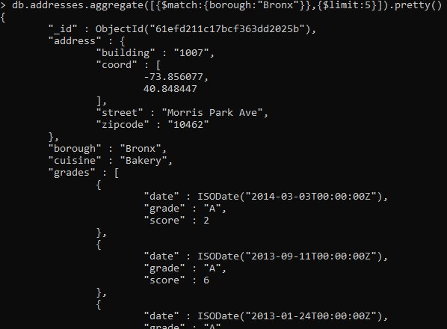

6. Write a MongoDB query to display all the restaurant which is in the borough Bronx.

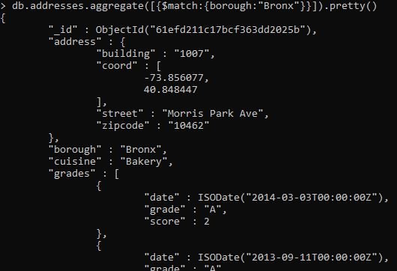

7. Write a MongoDB query to display the next 5 restaurants after skipping first 5 which are in the borough Bronx.

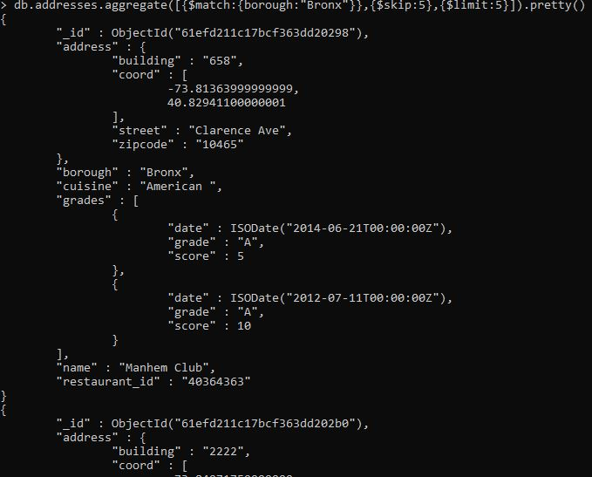

8. Write a MongoDB query to find the restaurants who achieved a score more than 90.

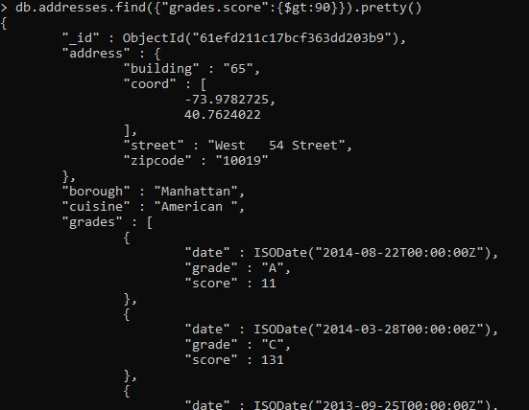

9. Write a MongoDB query to find the restaurants that achieved a score, more than 80 but less than 100.

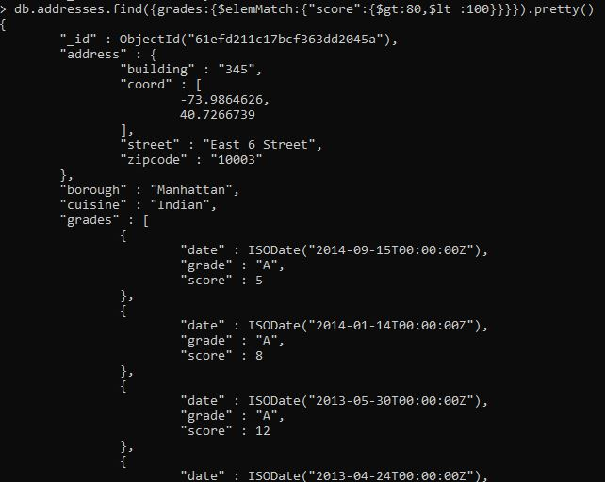

10. Write a MongoDB query to find the restaurants which locate in latitude value less than -95.754168.

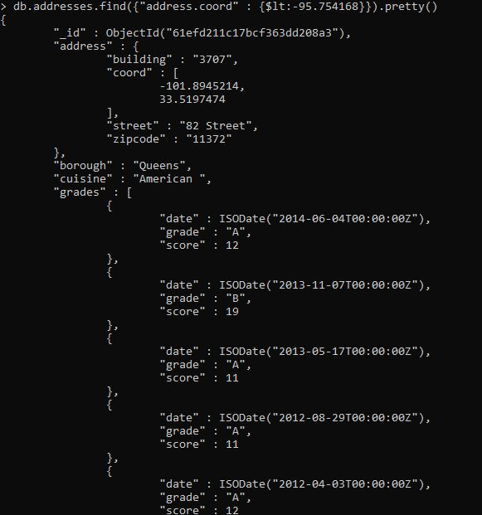

11. Write a MongoDB query to find the restaurants that do not prepare any cuisine of 'American' and their grade score more than 70 and latitude less than -65.754168.

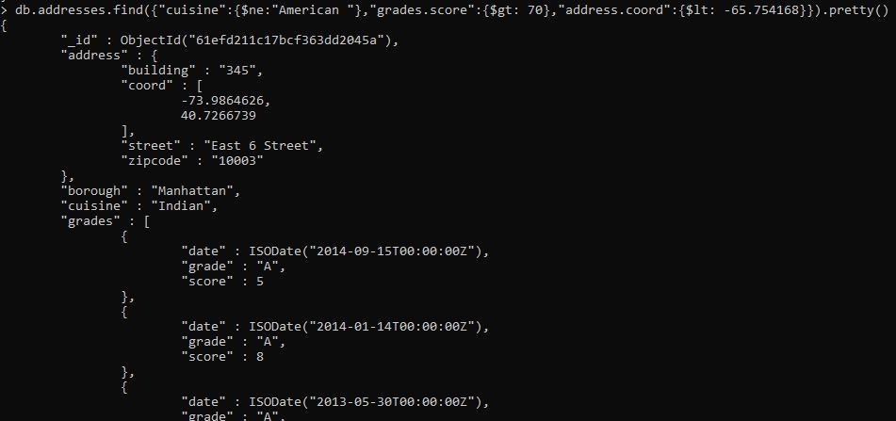

12. Write a MongoDB query to find the restaurants which do not prepare any cuisine of 'American' and achieved a score more than 70 and located in the longitude less than -65.754168.

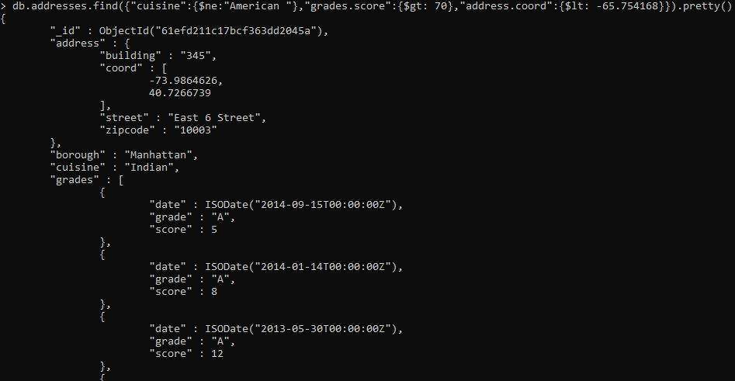

13. Write a MongoDB query to find the restaurants which do not prepare any cuisine of 'American ' and achieved a grade point 'A' not belongs to the borough Brooklyn. The document must be displayed according to the cuisine in descending order.

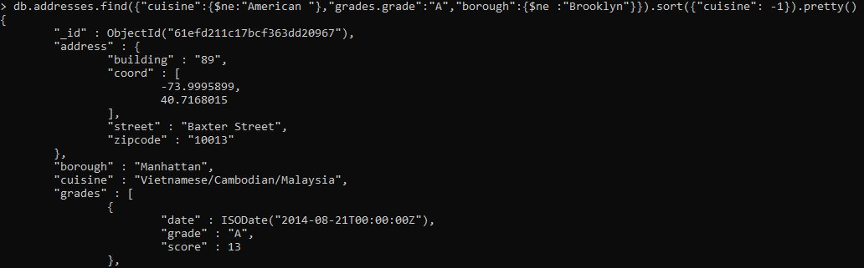

14. Write a MongoDB query to find the restaurant Id, name, borough and cuisine for those restaurants which contain 'Wil' as first three letters for its name.

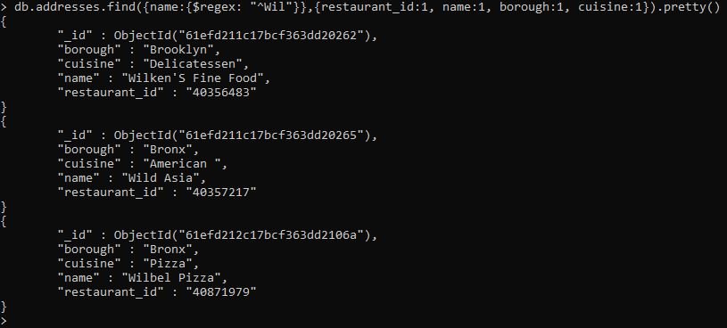

15. Write a MongoDB query to find the restaurant Id, name, borough and cuisine for those restaurants which contain 'ces' as last three letters for its name.

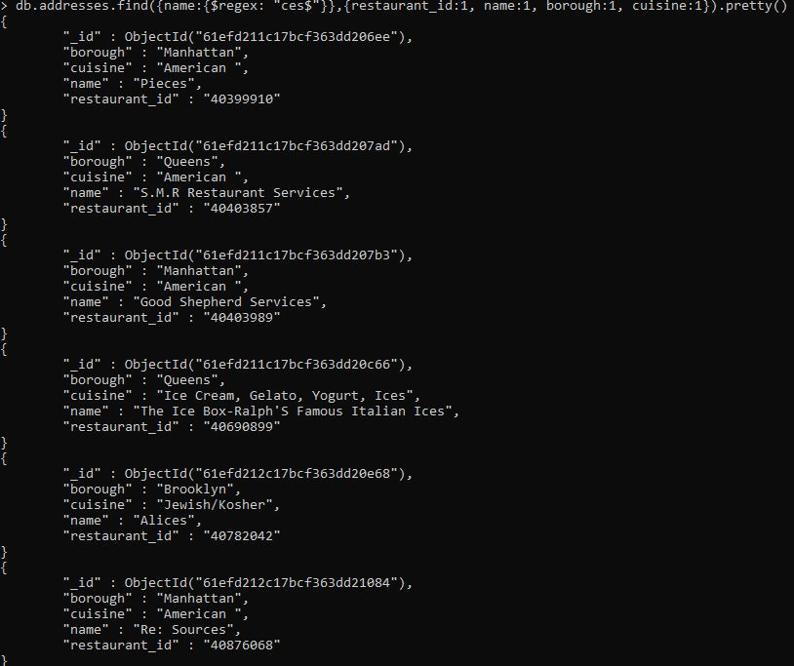

16. Write a MongoDB query to find the restaurant Id, name, borough and cuisine for those restaurants which contain 'Reg' as three letters somewhere in its name.

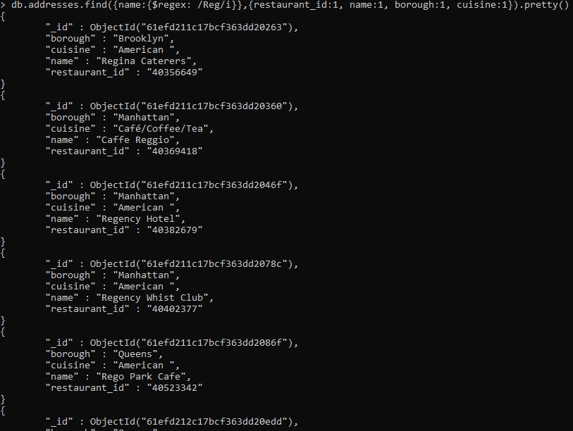

17. Write a MongoDB query to find the restaurants which belong to the borough Bronx and prepared either American or Chinese dish.

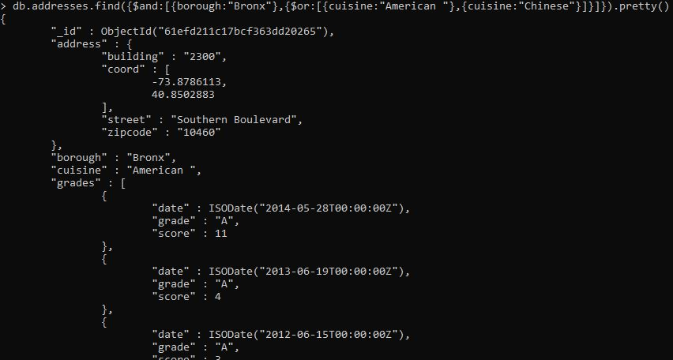

18. Write a MongoDB query to find the restaurant Id, name, borough and cuisine for those restaurants which belong to the borough Staten Island or Queens or Bronxor Brooklyn.

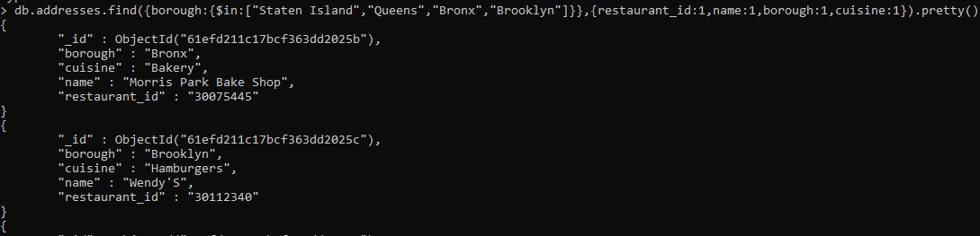

19. Write a MongoDB query to find the restaurant Id, name, borough and cuisine for those restaurants which are not belonging to the borough Staten Island or Queens or Bronxor Brooklyn.

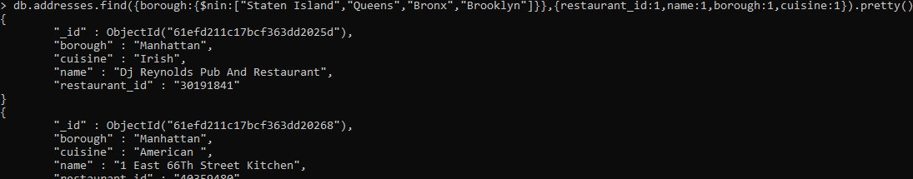

20. Write a MongoDB query to find the restaurant Id, name, borough and cuisine for those restaurants which achieved a score which is not more than 10.

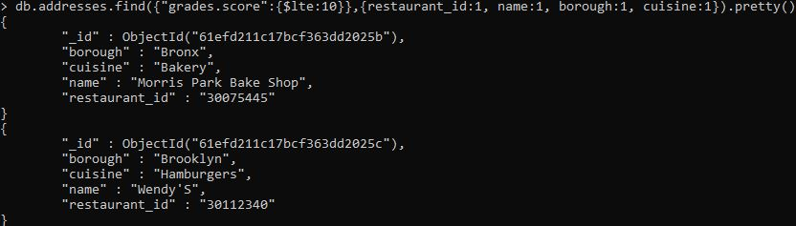

21. Write a MongoDB query to find the restaurant Id, name, borough and cuisine for those restaurants which prepared dish except 'American' and 'Chinees' or restaurant's name begins with letter 'Wil'.

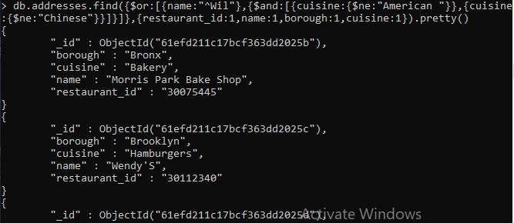

22. Write a MongoDB query to find the restaurant Id, name, and grades for those restaurants which achieved a grade of "A" and scored 11 on an ISODate "2014-08-11T00:00:00Z" among many of survey dates.

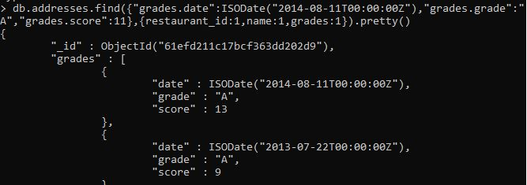

23. Write a MongoDB query to find the restaurant Id, name and grades for those restaurants where the 2nd element of grades array contains a grade of "A" and score 9 on an ISODate "2014-08-11T00:00:00Z"

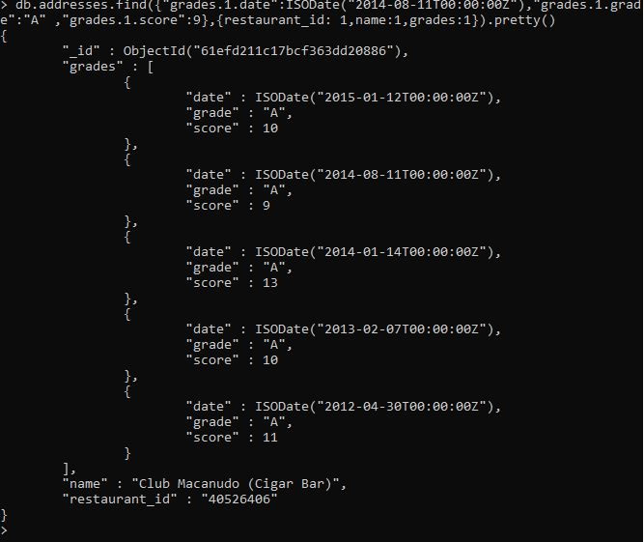

24. Write a MongoDB query to find the restaurant Id, name, address and geographical location for those restaurants where 2nd element of coord array contains a value which is more than 42 and upto 52.

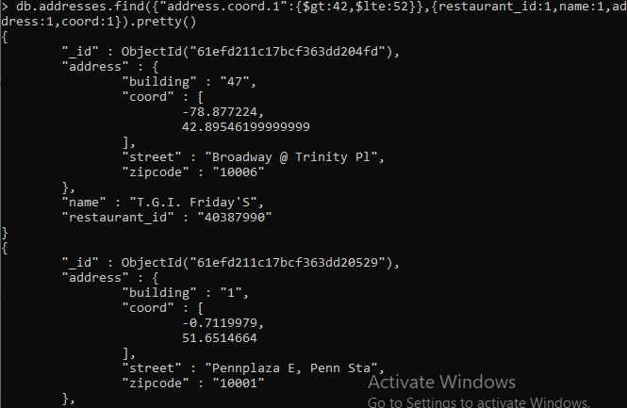

25. Write a MongoDB query to arrange the name of the restaurants in ascending order along with all the columns.

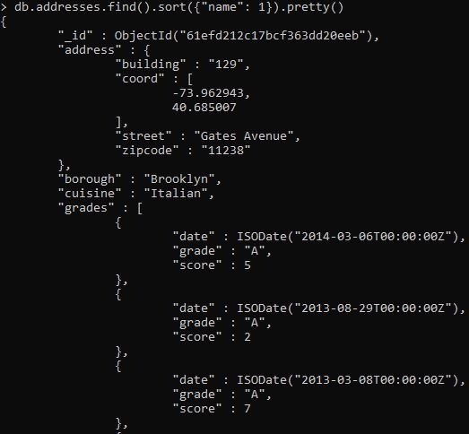

26. Write a MongoDB query to arrange the name of the restaurants in descending along with all the columns.

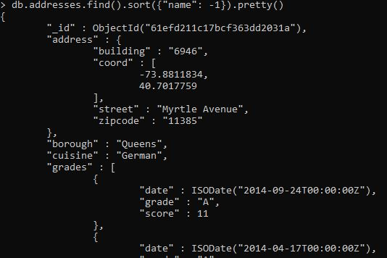

27. Write a MongoDB query to arranged the name of the cuisine in ascending order and for that same cuisine borough should be in descending order.

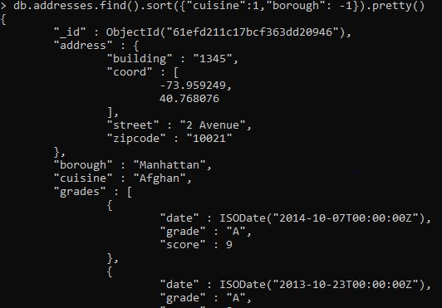

28. Write a MongoDB query to know whether all the addresses contains the street or not.

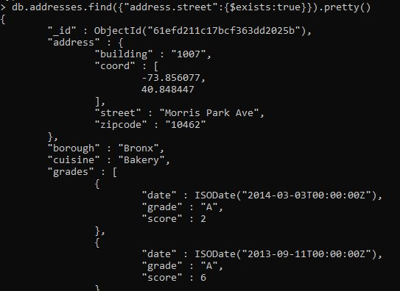

29. Write a MongoDB query which will select all documents in the restaurants collection where the coord field value is Double.

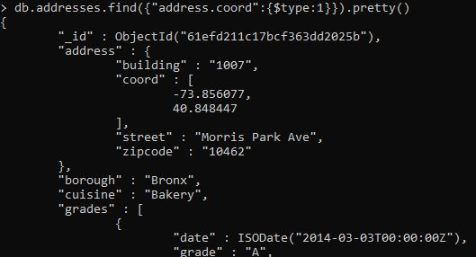

30. Write a MongoDB query which will select the restaurant Id, name and grades for those restaurants which returns 0 as a remainder after dividing the score by 7

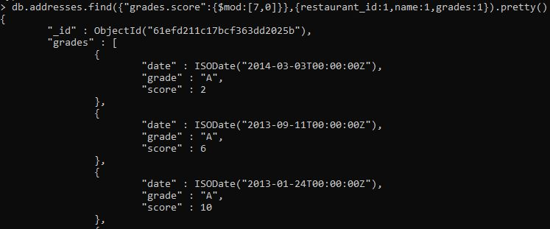

31. Write a MongoDB query to find the restaurant name, borough, longitude and attitude and cuisine for those restaurants which contains 'mon' as three letters somewhere in its name.

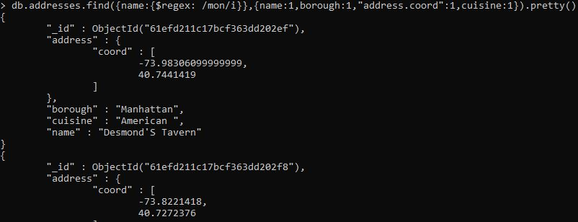

32. Write a MongoDB query to find the restaurant name, borough, longitude and latitude and cuisine for those restaurants which contain 'Mad' as first three letters of its name.

